Instrument Adjunct

✅ What Is an Instrument Adjunct?
# Source: AI Source: Provided by: [Data Path: Persons Table -> ID Column: 1, Name_En Column: Motasem Essam] -> From: [Chatgpt (GPT-4-turbo)] on [8/6/2025]
An instrument adjunct indicates the tool, means, or device by which an action is carried out. It shows how something is done — specifically, with what.
It answers the question:
- By what means?
- Using what?

🔸 Common Forms of Instrument Adjuncts:
# Source: AI Source: Provided by: [Data Path: Persons Table -> ID Column: 1, Name_En Column: Motasem Essam] -> From: [Chatgpt (GPT-4-turbo)] on [8/6/2025]
- Prepositional Phrases: with a hammer, by email, using a knife
- Adverbials (less common): electronically, manually

🔸 Examples of Instrument Adjuncts in Sentences:
# Source: AI Source: Provided by: [Data Path: Persons Table -> ID Column: 1, Name_En Column: Motasem Essam] -> From: [Chatgpt (GPT-4-turbo)] on [8/6/2025]
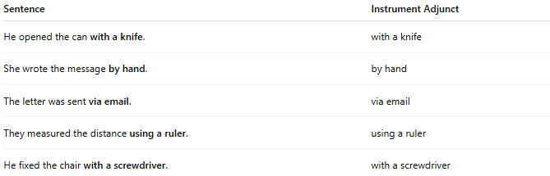
Sentence | Instrument Adjunct
He opened the can with a knife. | with a knife
She wrote the message by hand. | by hand
The letter was sent via email. | via email
They measured the distance using a ruler. | using a ruler
He fixed the chair with a screwdriver. | with a screwdriver

🔸 Position in the Sentence:
# Source: AI Source: Provided by: [Data Path: Persons Table -> ID Column: 1, Name_En Column: Motasem Essam] -> From: [Chatgpt (GPT-4-turbo)] on [8/6/2025]
- Final (most common): She cut the paper with scissors.
- Initial: With a key, he unlocked the door.
- Rare medial placement: She has, with care, handled the documents.

🔸 Reminder:
# Source: AI Source: Provided by: [Data Path: Persons Table -> ID Column: 1, Name_En Column: Motasem Essam] -> From: [Chatgpt (GPT-4-turbo)] on [8/6/2025]
An instrument adjunct provides important context, but it is not essential for the sentence’s grammatical structure.
🟢 "She opened the can."
🟡 "She opened the can with a knife." → Instrument adjunct adds method

